**FINAL REPORT**

ADAPTATIVE RESPONSES OF BIRDS TO HEAT STRESS IN SEMIARID REGIONS:

**IMPLICATIONS FOR REPRODUCTIVE BIOLOGY AND SPATIAL ECOLOGY IN THE RED-NECKED NIGHTJAR *(Caprimulgus ruficollis)***

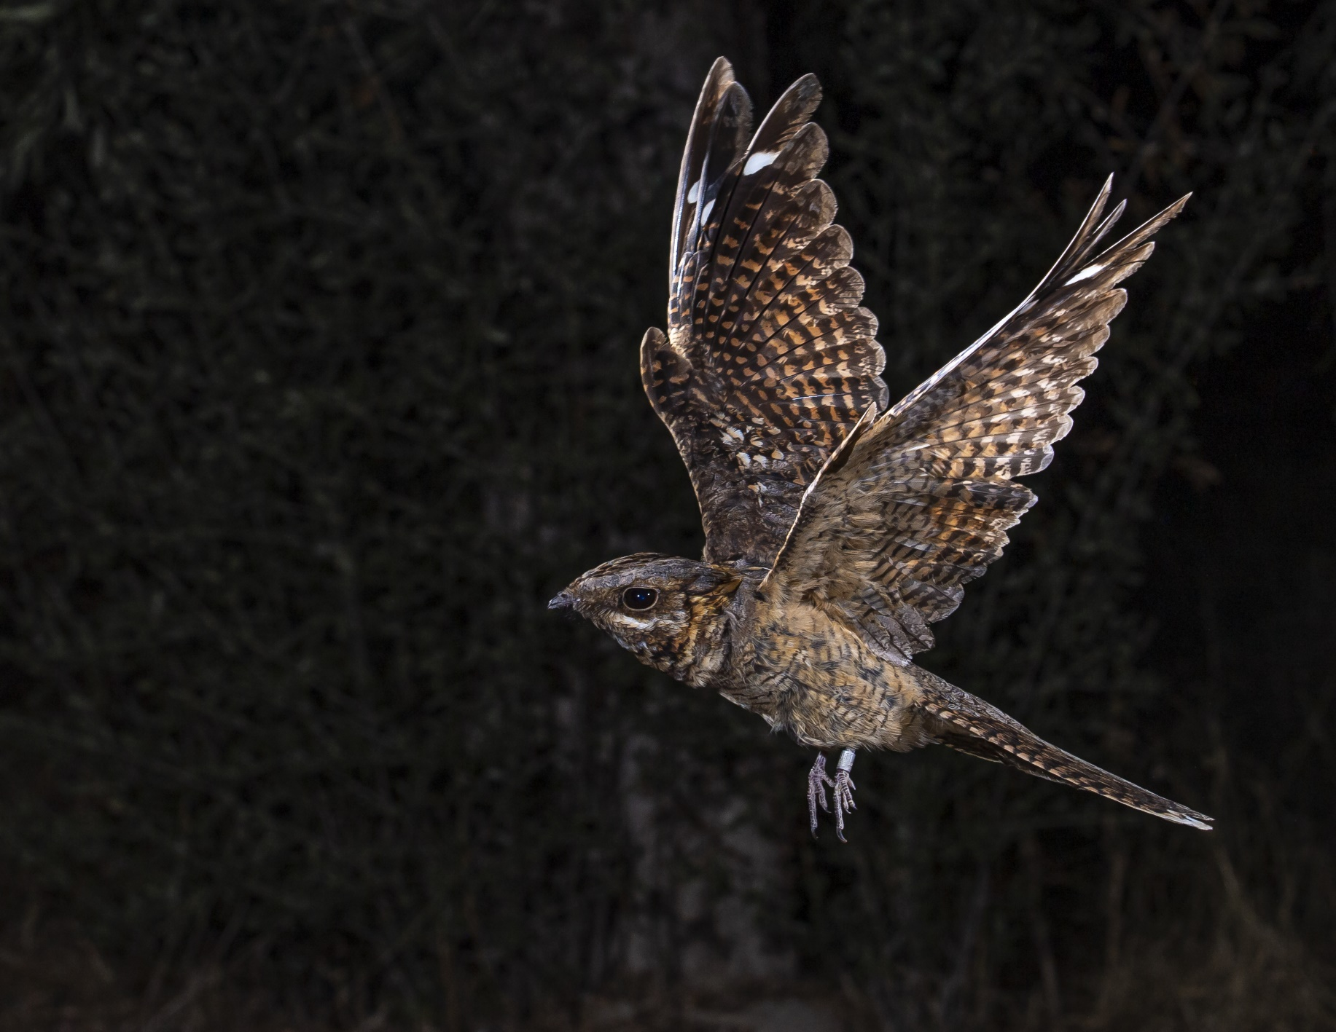

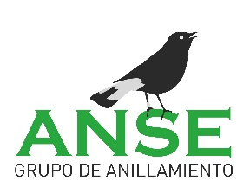**Author: José Manuel Zamora Marín**

**CALL FOR GRANTS FOR YOUNG RESEARCHERS (2022)**

**DECEMBER 2023**

**INDEX**

**1.** **CONTEXT** 3

**2.** **SUMMARY** 3

**3.** **INTRODUCTION** 3

**4.** **OBJECTIVES** 6

**5.** **MATERIAL AND METHODS** 7

**5.1.** **Study area** 7

**5.2.** **Fieldwork** 9

*5.2.1.* *Nest searching* 9

*5.2.2.* *Nest monitoring and adult trapping* 13

*5.2.3.* *Breeding monitoring* 16

**6.** **PRELIMINARY RESULTS AND DISCUSSION** 16

**7.** **PROVISION FOR SCIENTIFIC EXPLOITATIONOF S DATA** 21

**8.** **STRENGTHS AND WEAKNESSES** 21

**9.** **ECONOMIC BALANCE** 22

**10.** **ACKNOWLEDGEMENTS** 23

**11.** **BIBLIOGRAPHY** 23

1. **CONTEXT**

This document constitutes the final report of the results of the project entitled "Adaptative responses of birds to heat stress in semi-arid regions: implications on reproductive biology and spatial ecology in the red-necked nightjar (*Caprimulgus ruficollis*)", which was a beneficiary of the Call for Grants for Young Researchers launched by SEO/Birdlife in 2022. The document is presented as supporting report to describe in detail the work carried out by the author, with the help of collaborators, during the 2022 breeding season, as well as the preliminary results obtained and the possible ecophysiological implications on the target species. The results presented here constitute a brief but representative description of the information collected during the development of the project, although the data will be explored and analysed in depth during 2024 within the framework of the Juan de la Cierva – Training posdoctoral contract currently enjoyed by the author of this document at Miguel Hernández University. In fact, within the framework of this contract, the author has made a brief stay during the autumn of 2023 at the Doñana Biological Station under the supervision of Dr. Carlos Camacho Olmedo to work on a scientific manuscript on reproductive biology of the target species, which will serve as the basis for the following manuscripts where the data collected in this project will be exploited.

1. **SUMMARY (TO WRITE)**
2. **INTRODUCTION**

Global warming is one of the major challenges facing humanity, and its impacts on biodiversity and the sustainability of socioecosystems are beginning to be observed on a large scale (Cheung *et al.* 2013, Pennisi 2021). This increase in temperature, caused by human activities, is producing important changes in biological communities and ecological processes, mainly related to the change in the distribution of species and the loss of synchronization (phenological mismatch) of certain ecological processes (Trisos *et al.* 2020). Such changes are significantly affecting ecosystem services, with fatal consequences for the global economy (van der Geest *et al.* 2019) *.*However, the available information on the effects of global warming on the life history traits of species is still very scarce (Crick 2004, Carey 2009). In this context, most studies to date address the impact of heat stress induced by global warming on isolated ecological traits of species (e.g. productivity or phenology) (Both & Visser 2001, Fletcher *et al.* 2013), but there are hardly any studies that evaluate this impact from a comprehensive and multidisciplinary perspective, considering different life history traits together (Winkler *et al.* 2002, Pacifici *et al.* 2017). On one hand, this circumstance hinders an integrated and robust assessment of such impact on the long-term viability of populations and, on the other hand, limits our predictive ability to implement measures that minimize the negative effects of climate change on biodiversity.

Birds constitute an excellent model group for assessing the impact of climate change on biodiversity mainly due to their wide distribution (present in all continents and regions of the world), their evolutionary radiation (almost 10,000 described species), the extensive ornithological literature available, their intervention in a multitude of key ecological processes (seed dispersal, pollination and vector transmission, among others), its high movement capacity (which allows rapid changes in its distribution range), the migratory nature of many species and its ease of observation (Fiedler 2009). However, not all bird species are equally sensitive to heat stress from global warming. For example, birds that inhabit arid or semiarid regions are particularly sensitive to temperature increases, even if they are small, because many of these species are already close to their thermal tolerance limit (Şekercioğlu (Fiedler 2009)*et al.* 2012, Conradie *et al.* 2019). Therefore, any increase in temperature may compromise their survival in the short term. Similarly, it has been documented that rising temperatures have a more severe impact on migratory species than on resident species or species that make short migrations (Both *et al.* 2010).

Nightjars (Family Caprimulgidae) are insectivorous birds, some of them long-distance migrants, which are widely distributed in regions of warm and temperate climates worldwide. A common trait of the 100 species that make up this family is their markedly secretive habits, relegating their activity to twilight and nocturnal periods, and remaining practically inactive during the day. This aspect, together with their cryptic plumage and elusive behavior, has led this group of birds to be considered one of the least studied in the world (Braun & Huddleston 2009, Sáez *et al.* 2015). Other of the main ecological traits that characterize nightjars is that they do not build any nests, but deposit their eggs directly on the substrate, usually in open places (Cleere 2010). In addition, caprimulgids exhibit a broad spectrum of physiological and behavioral responses to temperature variations (Firman & Brigham 1993, Camacho 2013a), making them a widely used study model in the fields of movement ecology, phenology, and thermoregulation (Firman & Brigham 1993, Camacho 2013b, Camacho *et al.* 2014, O'Connor *et al.* 2018). This circumstance confronts some species from warm regions with a significant physiological challenge in dealing with heat stress during incubation. The magnitude of this challenge is increasing due to the general increase in temperatures, so the thermoregulation capacity of each species will greatly influence its geographical distribution and population trend in the near future (O'Connor *et al.* 2018). In addition, as well as other aerial insectivores (bats, swallows, and swifts, among others), several nightjar species are currently facing a high risk of extinction (Spiller & Dettmers 2019) and 40% of species are experiencing a sharp decline in their populations (Nebel *et al.* 2020). This aspect further emphasizes the need to study their responsiveness to different environmental stressors, such as exposure to high temperatures.

The red-necked nightjar (*Caprimulgus ruficolis*) is a long-distance migratory species and aerial insectivore that breeds in warm regions of the Iberian Peninsula and Northern Africa, and its wintering grounds are located at the south of the Sahara (Cleere 2010). Despite its wide distribution throughout the southern half of the Iberian Peninsula, the Spanish population has recently been classified as Vulnerable due to the significant decline it has experienced in the last decade, as well as a slight contraction in its distribution range (Camacho & Sáez-Gómez 2021). This species shows multiple habitat requirements during the breeding season, selecting different environments for breeding (e.g., scrublands or farmlands), feeding (e.g., roads and paths), and resting (e.g., forested areas) (Camacho *et al.* 2014). As a result of this plasticity in habitat selection, the red-necked nightjar can show high densities of breeding pairs in highly anthropized environments, such as certain types of agricultural landscapes (Cuadrado & Domínguez 1996, Aragonés 2003). Like other nightjar species, the red-necked nightjar places its nests directly on the substrate (Figure 1), without any intake of material, and generally in open areas exposed to direct solar irradiation (Sáez-Gómez & Camacho 2016). This species is considered one of the birds with the longest reproductive period of the Euro-Siberian avifauna (Camacho 2013a), and data collected in the Iberian southeast in recent years have documented its ability to make up to three breeding attempts in the same breeding season (Zamora-Marín et al. 2024, *in prep.*). These three circumstances (direct solar irradiation during incubation, prolonged reproduction period and multiple attempts to breed within the same season) expose nightjars to the effects of heat stress for a large part of their annual cycle. In addition, their main breeding grounds are located in warm and arid regions of the south of the Iberian Peninsula and North Africa, characterized by high summer temperatures. This climatic scenario is even more extreme in the Iberian southeast, considered the driest region of continental Europe (Armas *et al.* 2011). The climate models available for this region predict a temperature increase of 3ºC in the coming decades (Garrido *et al.* 2020). This circumstance could seriously compromise the viability of numerous critical processes in the life cycle of many thermophilic species that, like nightjars, are exposed to environmental conditions very close to their thermal tolerance limits. A major research effort is therefore urgently needed to determine how exposure to extreme thermal environments affects species that inhabit arid regions and how this relationship could influence the provision of key ecosystem services, such as pest control in agricultural landscapes.

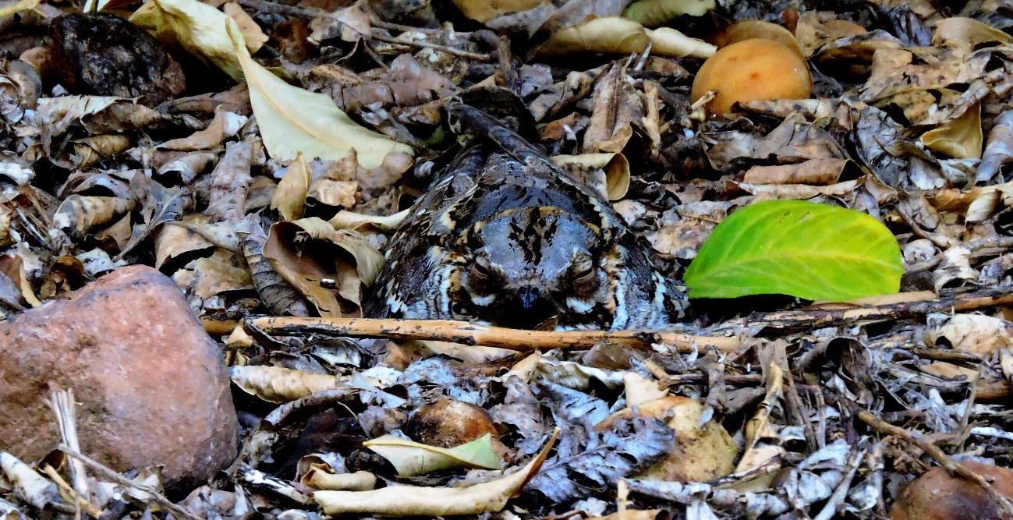

Figure 1. Female red-necked nightjar incubating eggs in a citrus plot located on one of the farm plots where the fieldwork of this project was carried out.

1. **OBJECTIVES**

The main objective of this project was to evaluate the effects of exposure to high temperatures during incubation on reproductive biology and spatial ecology in the red-necked nightjar. For that purpose, a combination of different monitoring devices based on novel technology has been used to collect very accurate data on the incubation pattern, the nesting attendance pattern from both mates, the exposure to extreme temperatures, the behavioral responses and the habitat use during the incubation period. The markedly precocial nature of the chicks (highly nidifugous behaviour) of this species makes it difficult for the study to extend also to the chick-rearing period. The specific objectives (SO) are as follows:

**(SO1) To evaluate the behavioral response of the red-necked nightjar to exposure to high temperatures in arid regions.**

Thermophilic bird species that place their nests in uncovered areas and directly on the ground need to implement behavioral strategies to cope with exposure to high temperatures. These strategies usually involve adopting behaviors to maintain constant body temperature (e.g. panting or hyperventilation) or outright avoiding such exposure to high temperatures (e.g. interspersing incubation periods with periods of temporary abandonment of the nest). The latter strategy would increase the eggs' vulnerability to predation. Then the eggs, not being incubated by nightjars (whose cryptic plumage reduces the detectability of the nest), would be visually exposed to potential predators. Such a circumstance could lead to higher rates of reproductive failure and compromise the long-term population viability under a future global warming scenario in which summer temperatures will be higher.

**(SO2) - To explore the effect of incubation temperature as a mediating factor of the relationship between intensity of attention to the nest, physical condition (weight and level of reserves) and spatial ecology (use of microhabitats and magnitude of movements) at the individual level.**

For that purpose, high precision data will be used on incubation and ambient temperature (exposure to air temperature), the time spent incubating by each pair mate (intensity of nest attendance), the physical condition of each member (measured as weight based on the level of reserves), and the range covered by both mates during incubation.

**(SO3) – To determine the degree of population-scale variability in the pattern of nest care by both sexes and the potential effects of differential exposure to high temperatures.**

Nightjars locate their nests in open areas, but these can vary significantly in the degree of vegetation cover and consequent exposure to direct solar radiation. In this context, nests located in areas with a greater vegetation canopy will be less exposed to extreme temperatures, implying a lower energy cost for adults for thermoregulation. The project will assess whether the degree of vegetation cover in the immediate environment of the nest affects the behavior of the breeding adults and the involvement of both sexes in incubation.

1. **MATERIAL AND METHODS**
   1. **Study area**

The study was carried out in an agricultural landscape located in the northwestern foothills of the El Valle y Carrascoy Regional Park (37°52'36"N, 1°16'24"W), in the center of the Province of of Murcia (Figure 2). This region is characterized by a warm and dry Mediterranean climate, with an average annual rainfall of 250-300 mm and an average annual temperature of 17-20º C, being considered the driest area of continental Europe (Armas *et al.* 2011). These semiarid conditions and the arrival of the Tajo-Segura water transfer system have contributed to the rapid expansion of intensive irrigated agriculture in recent decades, which currently extends to almost half of the region's surface area (Rupérez-Moreno *et al.* 2017).

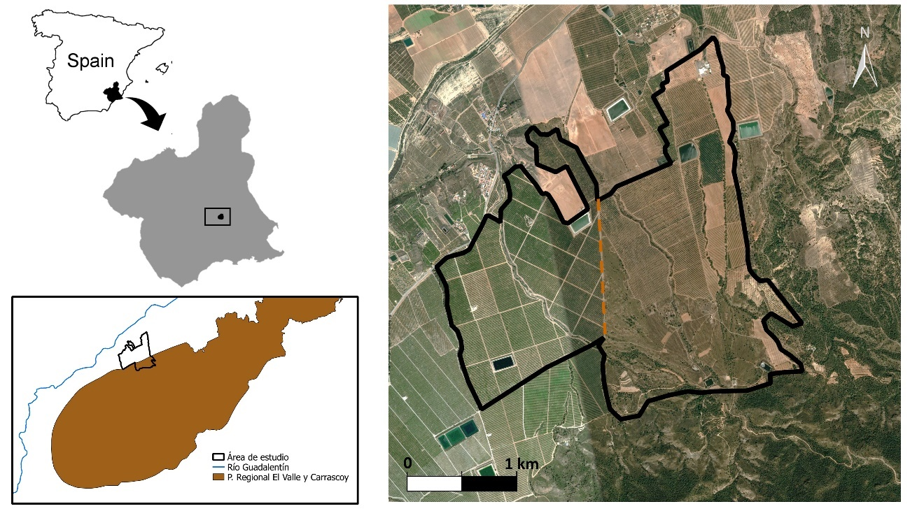

Figure 2. Location of the study area and configuration of the agricultural plots that make up the two farms where the fieldwork of this project was carried out. In the right picture, the farm under a conventional intensive agriculture regime is to the left of the dashed red line that divides the study area, while the farm subjected to integrated production farming regime is to the right of the red line. Note the proximity of the latter farm to seminatural Mediterranean scrub habitats in the foothills of the El Valle y Carrascoy Regional Park.

The study area consisted of two farms currently dedicated to intensive citrus cultivation, which are adjacent but differ in their agricultural management regime (Figure 3). The El Aguilucho farm, operated by the company EARMUR S.L., covers approximately 270 hectares, of which 154 hectares are used for grapefruit production and, in a marginal proportion, for lemon, kumquat, lime and citrus caviar production. The remaining area is occupied by Mediterranean shrubland, highlighting very well-preserved habitats dominated by esparto grass, mastic, wild olive, rosemary and other woody shrubs, as well as scattered and open patches of Aleppo pine (Figure 3d). This seminatural habitat is currently managed as a private hunting reserve and is mainly used for small game hunting, particularly the red-legged partridge (*Alectoris rufa*) and the wild rabbit (*Oryctolagus cuniculus*), although wild boar (*Sus scrofa)* is also stalked. The agricultural activity of this farm is governed by an integrated production regime, promoting the biological pest control through pheromone traps, and avoiding the use of synthetic fertilizers and phytosanitary products. On the other hand, the El Cañarico farm consists of 200 hectares exclusively dedicated to the cultivation of lemons and mandarins, and is governed by a conventional intensive agriculture regime (Figure 3b), which involves the regular application of agrochemicals (fertilizers and phytosanitary products) and seasonal pruning to control the growth of the trees. Unlike the other farm, El Cañarico is almost entirely surrounded by other areas dedicated to citrus cultivation, limiting its connectivity with seminatural habitats. The arrangement of the citrus crops on both farms is similar, being structured in long rows of trees, leaving wide corridors of 2-4 meters between them, which facilitate the location of nightjar nests during fieldwork. The study area is crossed by four small natural streams and is dotted with three irrigation ponds (two naturalized and one plastic-constructed), which provide surface water for wildlife. The different plots are connected by a network that extends along 32 kms of gravel tracks, which are exclusively used by agricultural workers and hunters, since access to both farms is restricted.

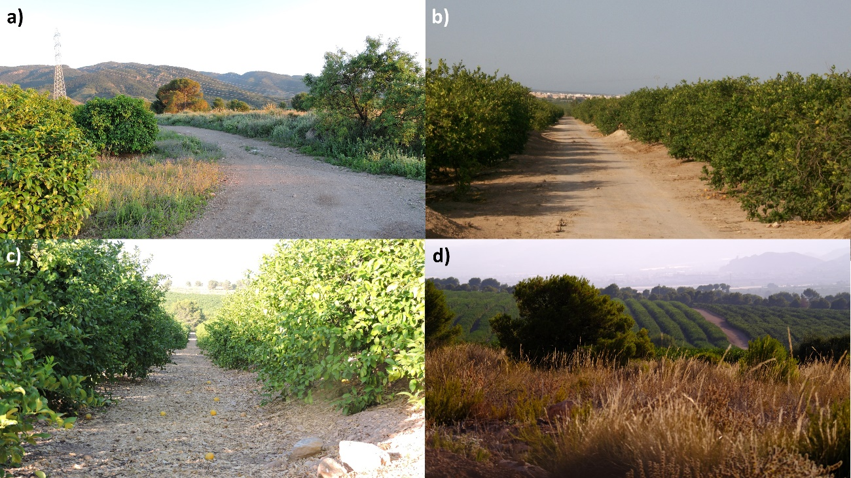

Figure 3. Appearance of different environments present within the study area. a) Grapefruit crops adjacent to a patch of Mediterranean scrub and open pine forest, located on the integrated production farm. Note the growth of ground vegetation cover among cultivated trees. b) Rows of citrus trees crossed by a sandy track on the conventional intensive farm. c) Detail of a corridor among citrus trees where nightjars generally locate their nests. d) Patch of Mediterranean scrub located between the two study farms.

* 1. **Fieldwork**

The fieldwork was started by the second week of May, matching the settlement of most of the target breeding population in the study area after their spring migration, and lasted until the end of August. The main objective of field visits was the search for nests, the capture/tagging of breeding adults and the review of the devices used to assess the incubation patterns, the behavior in the nest and the use of the habitat of the tagged individuals.

* + 1. *Nest searching*

Field visits for nest searching were carried out with a fortnightly frequency in each of the two farms, alternating the sampling of one farm in one week and that of the other farm in the following week, thus allowing a better optimization of the field effort. The search for nests was carried out by using the flash lighting technique (Figure 4b), which is based on the use of a LED flahslight to visually locate nocturnal animals (Jackson 2003, Camacho 2013a), which usually have a layer of ocular tissue (*tapetum lucidum*) that glows brightly when illuminated with artificial light. Night nest searching surveys began one hour after sunset, thus maximizing the probability of detecting breeding adults incubating in the nests, since during twilight periods both consorts tend to leave the nest to take advantage of the greater availability of ambient light and capture prey more easily (pers. obs.).

Night surveys consisted of a low-speed (10 km/h) vehicle transect along the gravel roads and tracks present on each farm (approx. 16 km per farm). This survey was carried out by at least two people (pilot and co-pilot), the minimum required to correctly carry out the sampling, and on several occasions by three or more people. During the survey, two field technicians were visually screening– with the help of a flashlight – the corridors present between the rows of citrus fruits, in order to detect the intense red glow reflected by the eyes of nightjars when they are illuminated. At the same time, field technicians also carried out a census of nightjars detected on roads or other types of substrates (fallow lands, barbed wire, etc.) from the car, taking advantage of the traffic lights projected by the vehicle.

For each nightjar detected, its location was recorded using a Garmin eTrex GPS, as well as its behavior (feeding, nesting, flight, etc.), the date and time of observation, the type of substrate (gravel road or corridor among citrus trees), and whether it had been attempted to capture (considering an attempt to capture the approach of a technician on foot carrying a hand-held flashlight and with the car lights off) and whether it had finally been captured (Figure 4c). The procedure applied to nightjars detected on the roads and in the corridors was similar. When detected, the vehicle was immediately stopped and technicians proceeded to capture nightjars with the help of a specially-designed hand net and a hand flashlight, turning off the vehicle's lights to avoid projecting shadows. The technician responsible for the capture of nightjars advanced slowly and without shoes (to minimize walking noise) towards the nightjar, while shining the beam of light from the flashlight on the animal's body. When the technician was positioned at a distance of approximately half a meter from the animal, an attempt was made to capture it using a hand-held net that was slowly placed on the animal (Figure 4a). Despite being an active trapping technique, the risks to animal welfare associated with this trapping methodology are very low since the hand net has been specially constructed for this purpose (with specific a mesh size and dimensions), and the mortality or injury probability associated with this method is considerably low (< 0.1%, own data).

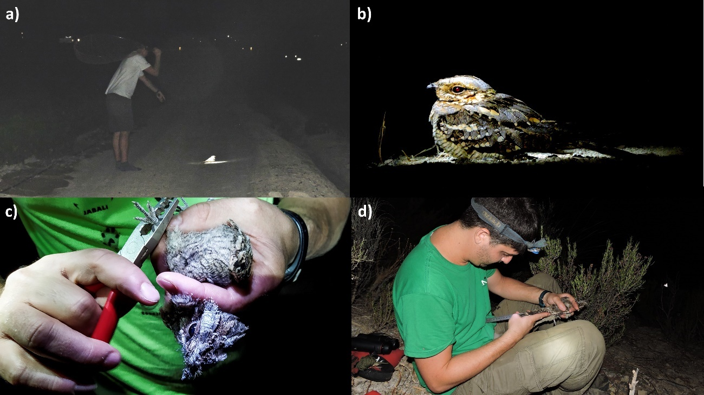

Figure 4. Different moments representing the capture and processing of nightjars in the study area. (a) Field technician proceeding to capture a red-necked nightjar detected while feeding on a gravel road. Note that the animal is completely illuminated by the beam of the flashlight, and that the technician carries a net in his right hand and that he is without shoes. (b) Adult red-necked nightjar dazzled by the beam of a nearby flashlight carried by a field technician. Note the incipient glow reflected by the animal's eyes when illuminated with the flashlight. (c) Ringing of a red-necked nightjar fledgling. d) Field technician measuring the wing length of a nightjar recently captured with a mist net.

When a nightjar was detected in a corridor, an approach was made in the same way as described above, but the capture of the animal was aborted if there was the slightest indication that it was incubating eggs, for example, when the animal was lying on the ground (not perched) and in a location prone to incubation (under the outer branches of a tree) (Figure 1). In such cases, the field technician approached the animal closely and turned off the flashlight to encourage the nightjar's flushing and to characterize the stage of reproduction and the number of eggs. For each nest located, its location, date and time of location, the name of the observers, the method of location (flash lighting or incidental encounter during daytime checks) were recorded, a unique nest code (e.g. 2022_A05) was assigned, and the number of eggs, the dimensions of each egg (width, length and weight) were also recorded, and embryo´s development was estimated using the flotation technique (Liebezeit *et al.* 2007). This technique consists of carefully depositing the egg in a clear plastic box filled with running water and recording the angle and height of the float (Figure 5a). If the egg has been recently laid, then it will lie at the bottom of the box, while it will begin to rise on its blunt side (gaining an angle of inclination in the buoyancy) as the embryo develops, finally floating upright during the last days of development. In this way, it was possible to estimate the laying date for each nest and, based on this information, determine how many days were still left for hatching, thus allowing a decision to be made on the suitability of installing or not the monitoring devices (temperature sensors, radio frequency antenna, GPS devices and camera traps). In general terms, the devices were installed in those nests for which it was estimated that there were still 7 days left until hatching, thus allowing a representative volume of data to be obtained for each nest. The nests were also marked with warning tape to avoid human disturbance (Figure 5c), and the location of each nest was immediately communicated to directors of each farm so that they could plan agricultural work while minimizing disturbances during reproduction (Figure 5d).

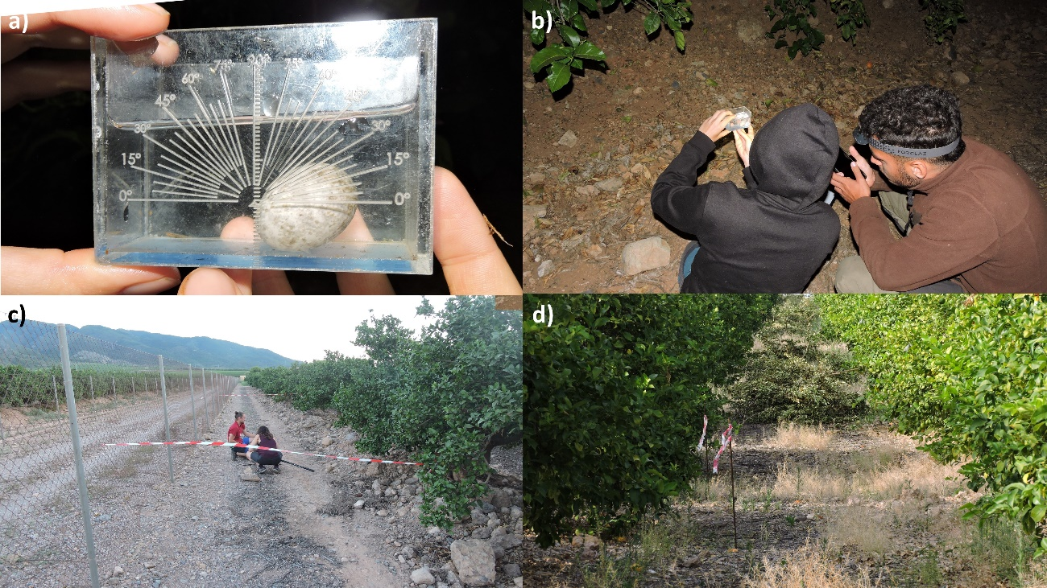

Figure 5. Determination of the developmental stage of the eggs, and nest marking. a) Red-necked nightjar egg inside the box for the flotation test. Note that the egg shows a float angle of 30º, indicating that it has been recently laid (<5 days). b) Field technicians determining the angle and float height of a nightjar egg. c) Field technicians checking the condition of a marked nest, which was extraordinarily located in the middle of an agricultural path. d) A nightjar nest marked with warning tapes, and remains of agricultural pruning appear at the bottom. It should be noted that the agricultural pruning was stopped before reaching the nest, thus highlighting the collaboration of farmers to avoid disturbing the reproduction of the species.

When a nest was located during the first week from the laying date, an MSR 145 temperature logger device (MSR Electronics GmbH, Switzerland) was installed to record variations in the thermal exposure of the nest and the incubating adult. Each device has two temperature probes, so one probe was installed between the eggs of the nest to record the incubation temperature, and the other was installed in the vicinity of the nest (≥40 cm of the eggs) to record control measures of temperature in the surrounding substrate, but always in an area with similar conditions of vegetation and shading to those of the nest (Figure 6).

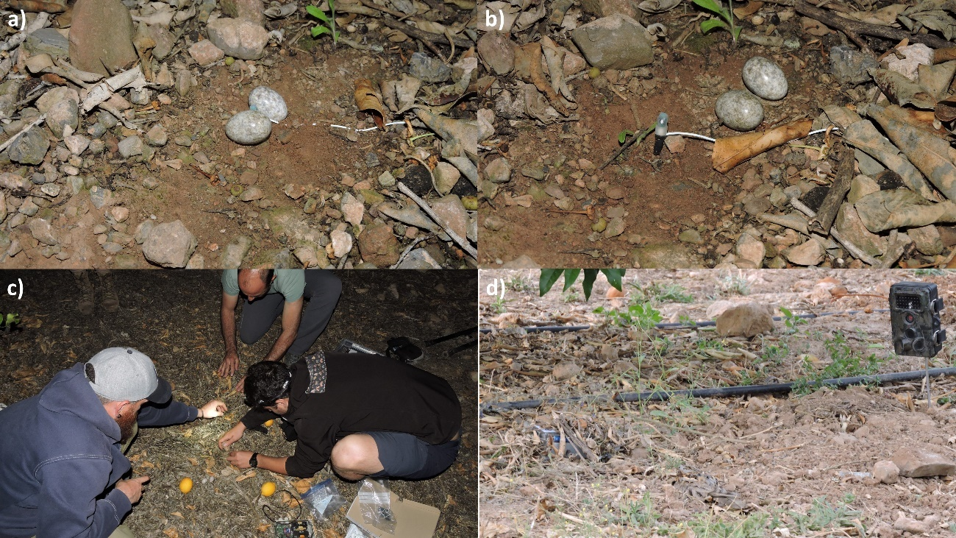

Figure 6. Installation of devices for monitoring incubation in red-necked nightjar nests. (a) Temperature sensor installed between two red-necked nightjar eggs. b) Eggs moved out by an adult red-necked nightjar from the temperature probe. After the observation of this behavior, the technique of installing the sensors was improved, remaining much more buried, and thus avoiding an aversive response by the adults. c) Field technicians installing a temperature logger in one of the nests. d) Red-necked nightjar nest monitored with the combination of all devices. Note the camera trap on the right, the radio frequency receiver on the left (covered with leaf litter), the female nightjar incubating in the lower center quadrant of the photo (the GPS backpack can be glimpsed behind her) and the temperature recorder in the lower right corner (next to the two stones).

* + 1. *Nest monitoring and adult trapping*

Night surveys for nightjar census and nest searching were followed by daytime visits for reproductive control of the nests located. These visits were carried out the day after or a few days after each night survey, and were aimed to capture the breeding adults of the nests targeted for incubation monitoring, and to check the correct functioning of the devices installed in previous visits. For each nest selected, breeding adults were captured using mist nets. In this context, it is worthwhile to note that the knowledge previously acquired in the framework of the long-term nightjar study conducted by the field technicians in the Iberian southeast pointed to the fact that the females incubate during the day, while the males assume most of the incubation doubts during the night, with occasional reliefs of the females (pers. obs.). The females were captured at dusk using a mobile mist net (Figure 7a), which was held at both ends (poles) by two field technicians who slowly moved it to the front of the nest, while a third technician accessed the nest from behind (through the tree that covered the nest) and flushed the female away by pushing her into the net. The males were captured on the same day. The mobile net was fixed in front of the nest with the help of ropes, in the same position that had been previously arranged to capture the female, and was left operational for about 1 hour after sunset. At dusk, the males usually make a first visit to the nest to relieve the females in incubation, although there is a period in which both consorts go out to nearby paths to feed taking advantage of the greater luminosity of twilight. In this way, the males were captured through fixed netting on their first visit to the nest, so that the time of disturbance in the nest for the capture of both mates was generally reduced to 2 hours at most (considering the time for capturing and marking the adults, and the time of installation of devices in the nest). Once captured, the adults were immediately removed from the net, ringed (if they have not previously ringed), aged and sexed based on reference literature (Gargallo 1994, Tornero & Sanchís 2017), weighed and tagged with a GPS device (PinPoint 50, LOTEK LTD) equipped with a VHF radio transmitter (PicoPip Tag, LOTEK LTD). installed on the animal's rump by means of a truss harness (Figure s 7b-c). The total weight of the backpack equipped with GPS and VHF radio transmitter was 2.9-3.1 g, which was usually about 3% of the weight of the tagged animals (weight range of the tagged adults 83.5-99.5 g). In addition, a small *pit-tag* or radiofrequency identification transponder (about the size of a grain of rice) was glued to the metal ring of each captured bird, thus allowing the incubation pattern of each mate to be recorded by means of a radiofrequency antenna installed in the nest (Figure 7d).To reduce handling time, and since both breeding adults would be captured two weeks later to retrieve the tracking devices , no other biometric measures were taken. The processing time of each animal was recorded from the time of its capture in the net until release, and never exceeded 5 minutes, generally encompassing 2-3 minutes of handling. This aspect is important because the experience gained in previous years suggests that a long handling time (e.g. 15 min) can lead to the nest abandonment by some breeding females.

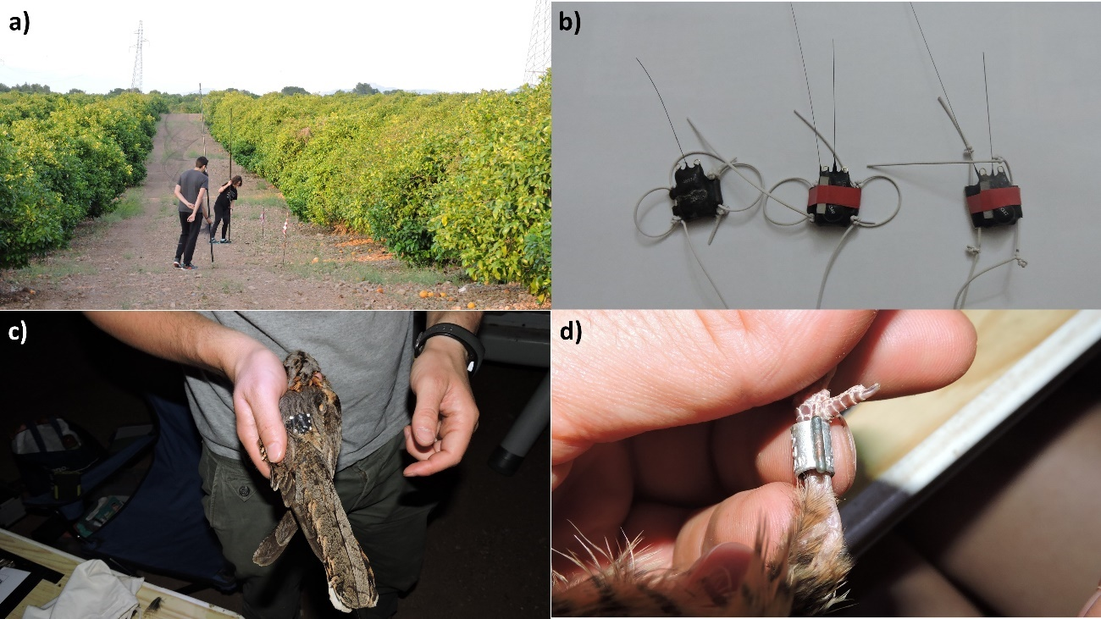

Figure 7. Different moments of capture and tagging of breeding adults. (a) Attempting to trap a female red-necked nightjar in the nest with a mobile net capture. b) Backpacks equipped with GPS+VHF devices and custom-made harness for quick deployment on nightjars during the incubation phase. c) Adult nightjar recaptured after monitoring and during the chick care phase to remove the GPS backpack and download the data. (d) A radio frequency transponder (*pit tag*) attached to the metal ring of a breeding nightjar. This small device (<0.1 g) contains a magnetic stripe code that is registered by an antenna installed in the nest when the nightjar resumes incubation.

After the tagging and release of the breeding adults, a radio frequency receiving antenna was installed in the nest, in order to record the entry, incubation, and exit of each consort, which have been equipped with a small transponder on its corresponding metal ring. This radiofrequency antenna consisted of a metal ring of 10 cm in diameter that was installed in the nest surrounding the eggs, and was carefully arranged half-buried to avoid interference or aversion by the adult nightjars (Figure 8). This antenna is connected to an electronic box that records and stores the records, which are taken at 5s intervals. Finally, about 50 cm from the nest, a camera trap was installed to assess the behavior of nightjars in different thermal exposure scenarios (e.g., direct solar radiation or shade), as well as to characterize the type of interactions with other wildlife (e.g., potential predators). Cameras (VicTising and Apeman models) were placed on a metal stick at a height of 30 cm from the ground, and was programmed to record 15s videos each time the motion sensor was activated.

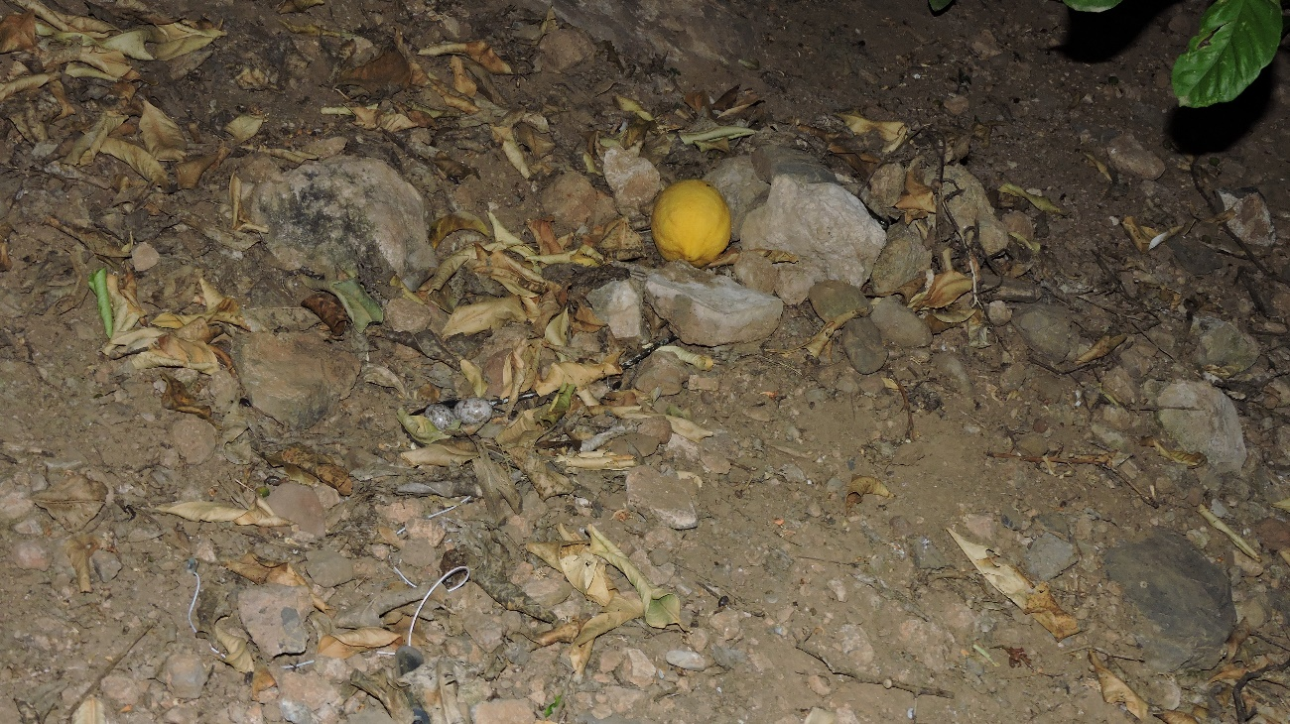

Figure 8. Radio frequency receiver and temperature loggers installed in a red-necked nightjar nest. The black wire that surrounds the eggs above ends in a circular antenna that is half-buried and camouflaged, and the wire connects the antenna to a register box hidden among the stones. The white wires coming out of the nest from below end up in two temperature probes, one placed between the eggs and one outside the nest.

* + 1. *Breeding monitoring*

Once the breeding adults had been tagged and the devices installed in the nests, nests were checked approximately every 3-5 days to assess the correct functioning of the devices, replace the batteries or memory cards of the camera traps and radio frequency receivers in the nest, and determine if hatching had already occurred. This last aspect is crucial for planning the session of ringing the chicks and capturing the breeding adults in order to retrieve the GPS+VHF tracking devices (essential for downloading the data, and also for reusing the devices) and the *pit-tags* attached to the metal rings. The visit to each nest monitored with devices involved the approach and flushing of the breeding adult while incubating, so the start and end time of each visit was recorded so as not to incorporate noise into the analysis of the incubation pattern data.

When the chicks reached or exceeded 5 days old, the breeding adults were captured again with mist nets to retrieve the devices and download the data, as well as to record all the biometric parameters usually taken in the monitoring that the ANSE Ringing Group carries out with this species since 2017. For these captures, the breeding territory of each pair was carefully screened during the day to locate the female next to the chicks, since chicks show a markedly nidifugous behavior and leave the place of birth at 1-2 days of age, beginning to disperse together and progressively from the nest. To this way, females were mostly captured at dusk using a mobile net, and males were captured in the early evening using a fixed net. To capture males, we set up a fixed mist net in front of the nest 30 min before sunset and placed chicks into a transparent plastic box (open at the bottom) to avoid parent-induced chick movements far from the trapping area. This technique allowed also to ensure safe conditions for the chicks during the capture works, while maximizing the probability of capturing the breeding male. Once captured, the two adults were processed to record all those biometric parameters that were not previously collected during the ringing session conducted at incubation, since in that time only essential parameters were recorded to reduce as much as possible the handling time during this critical phase. These measurements correspond to wing length, P8 and P10, keel size, stomach volume, fat score, brood patch and muscle, as well as the age, sex and weight of the bird that were previously recorded during the first capture. The chicks in each nest were also identified with a metal ring, weighed and measured, in order to evaluate their survival during their first days of juvenile dispersal.

1. **PRELIMINARY RESULTS AND DISCUSSION**

A total of 30 field visits were carried out throughout the breeding season in order to count nightjars, to search for nests, to tag breeding adults and monitor the reproduction of target pairs. This fieldwork allowed us to find 30 nests, 23 of them on the farm under the conventional intensive regime and 7 on the farm under the integrated production regime (Figure 9). Of the total number of nests located, 18 of them were found in the incubation phase, while the remaining 12 were found during the chick-brooding phase. Of the 18 nests located during the incubation phase, 16 were monitored with temperature loggers (partial monitoring), while 8 of these were additionally monitored with camera traps, radiofrequency receivers in the nest (to assess the nest attendance pattern of each mate) and GPS+VHF devices to obtain information about the home range of both breeding adults (full monitoring). Since nest monitoring was done simultaneously, the amount of fully monitored nests was limited by the number of GPS+VHF devices available, as well as the number of camera traps available.

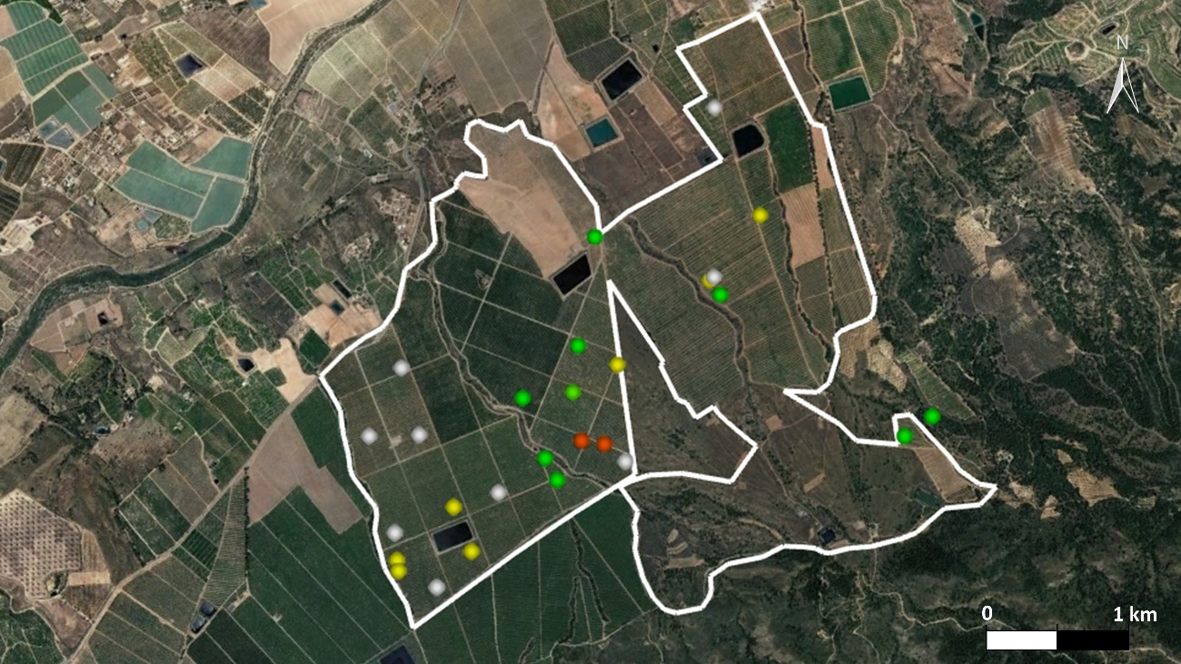

Figure 9. Distribution of red-necked nightjar nests located during the development of this project. Nests that have been monitored simultaneously with temperature loggers, radiofrequency receivers, GPS+VHF devices and camera traps are marked in green, whereas those that have been monitored exclusively with temperature sensors are marked in yellow, those that have not been monitored with any of these devices are marked in red, and those that were located during the chick-brooding phase (so they could not be monitored during incubation) are marked in gray.

Incubation monitoring by using temperature loggers made it possible to determine in detail the incubation pattern of the target species, and also to obtain information on the level of thermal exposure to which these birds are exposed during incubation. The temperature recorded by the control probe fluctuated markedly throughout the day, while the temperature of the nest showed considerably more constant temperature values (Table 1). In this context, the maximum temperature recorded by the control sensors located in the vicinity of the nest was 72.4º C. The data collected also make it possible to identify the periods in which the adults temporarily leave the nest or cease incubation during the night, as the temperature of the nest decreases drastically. The visualization of the collected data has made it possible to recognize an interesting behavior that occurs after hatching. Nightjar chicks show a markedly nidifugous behavior, and definitively leave the nest within a few days of hatching. However, the incubation patterns obtained show that the chicks provisionally leave the nest on the same day they hatch, probably to move to a closer area that is more open and where the adults can more easily maneuver to feed them (pers. obs.), but before dawn the chicks return exactly to the same place of birth (Figure 10). This behavior is especially interesting if we consider that nightjars do not build any nests, that is, they do not provide material or dig a cup at the point where they lay the eggs. Therefore, there are no visually distinctive elements that act as a spatial reference for the chicks to return to the place of birth, so this daily movement is probably guided by one of the adults.

|  |  |  |
| --- | --- | --- |
|  | **Control Probe** | **Nest Probe** |
| **T Min (ºC)** | 11.55 | 18.18 |
| **T Max (ºC)** | 62.97 | Article 42.89 |
| **Average T (ºC)** | 29.83 | 35.87 |
| **T Standard Deviation** | 1.34 | 5.47 |

Table 1. Summary of parameters recorded by the temperature logger in the nest “2022_C03”, where the highest thermal stability (lowest standard deviation) of the nest can be appreciated as compared to the control site.

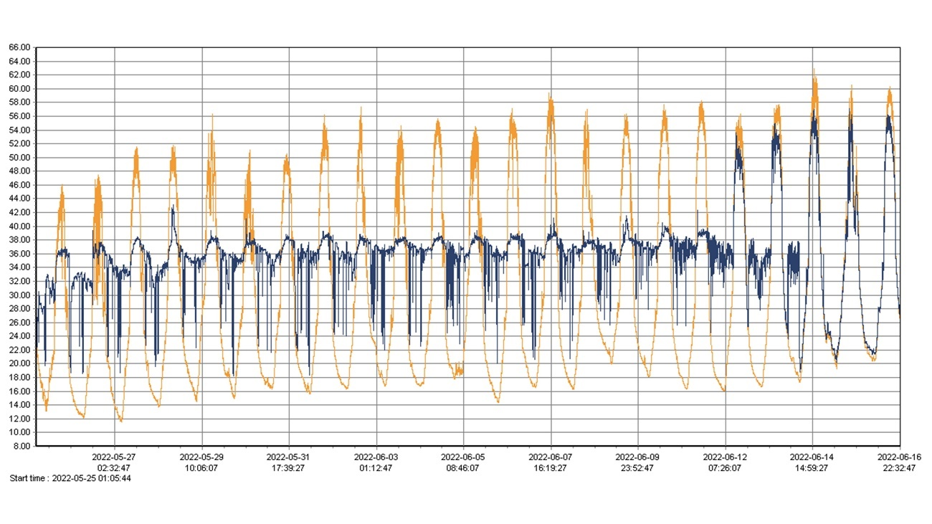

Figure 10. Incubation pattern of the "2022_C03" nest obtained by continuous monitoring with temperature logger from the moment of its finding (May 25) until days after hatching (June 16). The temperature of the nest is represented by the blue line, while the control temperature is represented by the orange line. Note that after hatching (June 12), the chicks leave the nest for two nights (since the temperature of both probes equalizes at night), but return to the nest during the daytime (because during the day both temperatures again show a pattern similar to that of incubation).

The use of radiofrequency receivers in the nest made it possible to record the identity of the incubating bird, allowing for the calculation of the time spent by each of the mates (male and female) to the incubation. This information is complementary to that collected by the temperature logger, and analyzed together offers the opportunity to comprehensively assess the incubation pattern and energy investment of each mate in this reproductive phase. The data collected allow us to conclude that nightjars show a very well-structured share of incubation duties during the daily cycle, with females being in charge of incubation during daylight hours, and males assuming this task almost exclusively at night (Figure 11). However, this pattern is somewhat flexible between breeding pairs, and data collected from other nests show some reliefs throughout the night, but it is always the male who takes on most of the nighttime incubation.

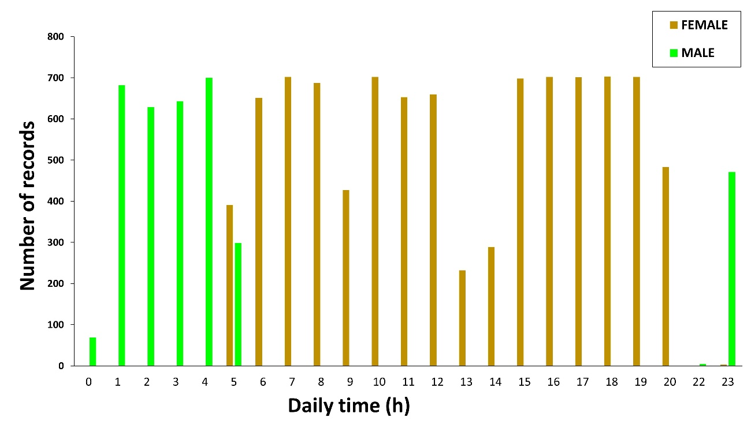

Figure 11. Pattern of nest attendance by each of the mates in one of the breeding pairs monitored within the framework of this project. The vertical axis shows the number of recordings (= readings) taken by the radiofrequency receiver for each mate (male and female). Note that the radiofrequency receiver records a reading every 5 s when it detects a *pit tag* (= incubating nightjars) in its working field. The horizontal axis reflects the 24 hours that make up a day. It should be noted that the female incubates almost exclusively during daylight hours, the male does so exclusively at night, and at sunset (10 p.m.) there is a relatively long incubation off-bout from both mates, probably associated with taking advantage of higher luminosity at twilight for which nightjars show a greater foraging efficiency.

The data collected by GPS devices made it possible to determine the home range and habitat use of the monitoring breeding pairs during incubation. In total, both parents (male and female) were GPS-tagged in six nests, while in two other nests only one of them could be tagged. The GPS devices recorded approximately 430 positions per individual tagged, corresponding to an average of 19 days of nightjar activity. Although the data have not yet been thoroughly analyzed, a prospective visualization shows an overall larger home range for females, although this pattern is much clearer in some pairs (Figure 12) as compared to others (Figure 13). Some nightjars routinely moved to feeding grounds located 8 km away from the nest, preferably selecting vegetable (especially peppers and melons) and aromatic crops.

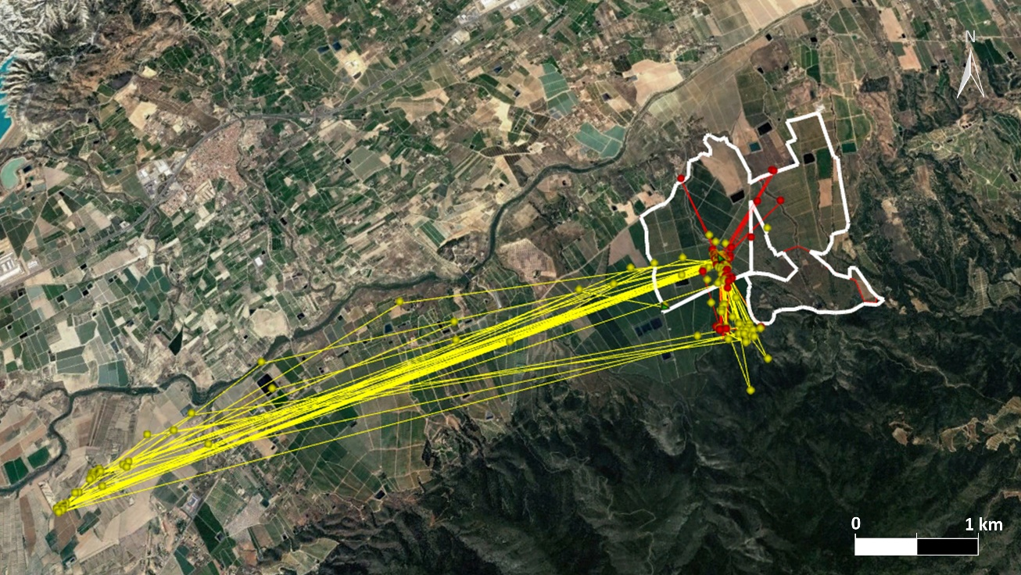

Figure 12. Home range of a breeding pair of nightjars (nest 2022_C10) tagged with GPS devices within the framework of this project. The female (yellow) routinely moved to vegetable crops located 8 km away to forage, while the male (red) showed a much smaller home range and practically only used citrus crops (within and adjacent to one of the study farm plot) for foraging.

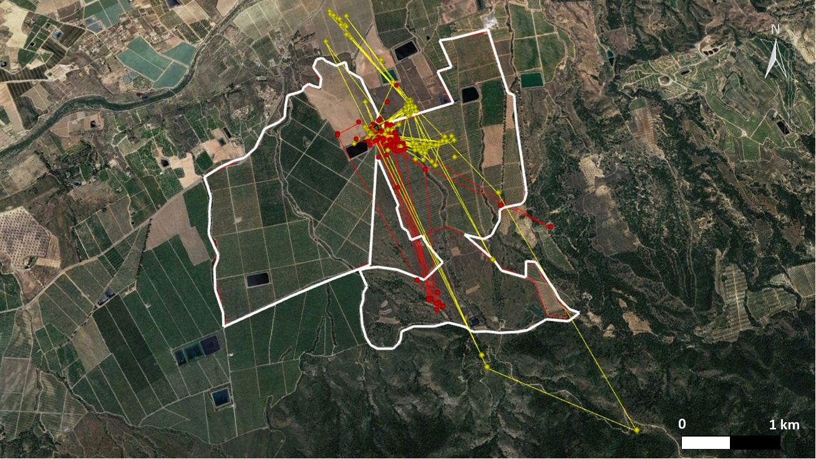

Figure 13. Home range of a breeding pair of nightjars (nest 2022_C11) tagged with GPS devices within the framework of this project. Both mates had significantly smaller home ranges as compared to the above case. The female (yellow) eventually moved to citrus crops located north of the study farms, as well as Mediterranean forest areas located at higher altitudes and south of the study farms. The male (red) showed a slightly smaller home range and mostly used an area of Mediterranean scrubland attached to the farm for foraging.

Visual material collected by trail cameras is properly stored and organized, although it has not yet been viewed or processed, since more than a thousand videos have been accumulated. Currently, the beneficiary of this grant is supervising a Master's Thesis at the University of Murcia (Master's Degree in Protected Areas, Natural Resources and Biodiversity) aimed at processing videos of nightjars during incubation and assessing their behavioral responses to sunlight exposure, as well as interactions with other potentially predatory species. On the other hand, due to the significant fieldwork load assumed during the development of this project, the nesting microhabitat characterization (SO3) could not be conducted due to a significant time overlap of nest searching and adult tagging tasks (priority action) in the second half of the breeding season with the dates scheduled to record nest selection data from the earliest nests of the breeding season.

1. **PROVISION FOR SCIENTIFIC EXPLOITATIONOF S DATA**

The beneficiary of this grant currently works as a Juan de la Cierva – Training postdoctoral researcher in the Area of Ecology at the Miguel Hernández University, where he joined last January 2023. After a few months of adaptation and completion of pending manuscripts related to his previous contract (in the Dpt. of Zoology and Physical Anthropology at the University of Murcia), the beneficiary will use the next year of his postdoctoral grant to exploit the data collected within the framework of this project. In fact, he has already made a brief research internship at the Doñana Biological Station under the supervision of Dr. Carlos Camacho, aimed at preparing a first manuscript on reproductive biology of the study species. In addition, a second two-month internship at the same research center is already programmed for January 2024 in order to set a roadmap for the preparation of next scientific manuscripts based on the data collected in this project. In this context, the beneficiary also plans to apply for a postdoctoral internship grant (the José Castillejo Call for International Research Internships) to carry out a three-month stay under the supervision of Dr. Martin Bulla at the Max Planck Institute for Ornithology (Germany). Both collaborators are international expertise in the fields of nightjar ecology (Carlos Camacho) and avian incubation patterns (Martin Bulla), so the comprehensive utilization of the data collected and their consequent publication in prestigious journals is guaranteed.

1. **STRENGTHS AND WEAKNESSES**

The development of the project has been possible thanks to a set of logistical aspects, many of which had been previously managed by the beneficiary of the call. For instance, the incorporation of a training Master student with previous experience in wildlife management was pivotal to be able to tackle all the fieldwork, while the project contributed to her training in relevant abilities such as study design, work planning, capture techniques and radio tracking. In this context, a list of strengths and weaknesses of the project is provided below in order to identify which strengths and weaknesses have motivated the achievement (or not) of the proposed objectives. To this way, identifying weaknesses can be particularly useful to better plan future sampling seasons and to properly adjust the project objectives with the available logistical and human resources.

|  |  |
| --- | --- |
| **STRENGTHS** | **WEAKNESSES** |
| * Incorporation of a training student | * High field workload |
| * Important network of volunteers | * Synchronization in nest tracking |
| * Integration of the project into ANSE | * Shortage of qualified staff to delegate monitoring tasks |
| * Collaboration from farmers | * Underestimating time for data analysis |
| * Network of collaborating researchers (Nightjaring, Max Planck Institute) | * Lack of staff/time for video processing |
| * Extensive previous experience with the study species | * Reduced number of devices available for tracking |

1. **ECONOMIC BALANCE**

The economic viability of this project has been guaranteed by the trajectory of the long-term study conducted by the ANSE Ringing Group with the study species since 2017. This monitoring has allowed to establish some collaborations with small private companies, which have economically contributed to face some costs of breeding monitoring seasons and thus to alleviate the economic contribution provided up to date by the people in charge of the project. In this context, the grant provided by SEO/Birdlife has allowed the acquisition of GPS devices, which have also been partially covered thanks to two other small grants provided by private companies (EARMUR S.L. and Ideas Medioambientales S.L.). The remaining costs has been paid by ANSE and by the beneficiary of the call itself. The total cost of implementing the project amounts to € 5,246.70 (Table 2). However, it is worth mentioning that most of the material used in this project has been kindly provided by the Max Planck Institute for Ornithology, through the project supervisor Martin Bulla, which has notably reduced the costs derived from the fieldwork.

|  |  |  |  |  |  |
| --- | --- | --- | --- | --- | --- |
| **Type of expense** | **Concept** | **Units** | **Unit Price** | | **Total Price** |
| Material | GPS PinPoint 50 | 6 | €465.00 | €2,790.00 | |
| Material | VHF PicoPip Tag | 6 | €170.00 | €1,020.00 | |
| Taxation | Shipment GPS and Brexit | 1 | €886.00 | €886.00 | |
| Fuel | Displacement | 34 | €9.50 | €323.00 | |
| Material | SD Cards | 5 | €4.45 | €22.25 | |
| Material | Fungible | - | - | €71.50 | |
| Material | Ringing material | - | - | €133.95 | |
|  |  |  | TOTAL | €5,246.70 | |

Table 2. Breakdown of the economic costs associated with the implementation of the project.

1. **ACKNOWLEDGEMENTS**

The development of this project would not have been possible without the financial support of the Spanish Ornithological Society (SEO/Birdlife), whose grants for young researchers have made it possible to acquire part of the devices used for tagging nightjars. The environmental consulting company Ideas Medioambientales S.L. also contributed financially to cover the expenses derived from the fieldwork, and the purchase of some devices. The Association of Naturalists of the Southeast (ANSE) contributed to the project by making all the administrative and logistical resources available, facilitating the processing for the purchase of the devices, supporting the application of the relevant fieldwork licenses and providing its network of volunteers, many of whom actively participated in the field visits. Martin Bulla, from the Max Planck Institute for Ornithology, kindly provided the devices for monitoring the incubation (radiofrequency receivers, *pit tags*, and temperature loggers), as well as all the necessary protocols for the proper application of the field methodology. Special thanks should be given to Mariangeles Lozano Arnaldos, a student of the Master's Degree in Wildlife Management at the University of Murcia, who carried out her training internship in an outstanding way within the framework of this project. Antonio Zamora López, Sarah Díaz García and Mario León Ortega actively contributed to the project since its beginning, allowing work teams to be split and performance to be optimized in the field. The company EARMUR S.L. partially financed nightjar monitoring works prior to the project, which were crucial in obtaining the necessary experience in the capture, marking and monitoring of nightjars. The companies EARMUR S.L. and El Cañarico S.L. allowed access to their agricultural facilities and offered to collaborate actively whenever required. The fieldwork would not have been possible without the invaluable contribution of a multitude of volunteers, including Francisco J. Pagán Sarmiento, Maripaz Aldeguer Aldeguer, Pablo Espinosa, Ángel Palacios and Vicente Pérez Baró. Pedro Sáez Gómez and Carlos Camacho Olmedo (Nightjaring Group) contributed to the conceptualization of the project and provided timely recommendations for the improvement in the application of field methodologies.

1. **BIBLIOGRAPHY**

**Aragonés, J.** 2003. Breeding biology of the Red-necked Nightjar Caprimulgus ruficollis in southern Spain. *Ardeola* **50**: 215–221.

**Armas, C., Miranda, J.D., Padilla, F.M. & Pugnaire, F.I.** 2011. Special issue: The Iberian Southeast. *J. Arid Environ.* **75**: 1241–1243.

**Both, C., Van Turnhout, C.A.M., Bijlsma, R.G., Siepel, H., Van Strien, A.J. & Foppen, R.P.B.** 2010. Avian population consequences of climate change are most severe for long-distance migrants in seasonal habitats. *Proc. R. Soc. B Biol. Sci.* **277**: 1259–1266.

**Both, C. & Visser, M.E.** 2001. Adjustment to climate change is constrained by arrival date in a long-distance migrant bird. *Nature* **411**: 296–298.

**Braun, M.J. & Huddleston, C.J.** 2009. A molecular phylogenetic survey of caprimulgiform nightbirds illustrates the utility of non-coding sequences. *Mol. Phylogenet. Evol.* **53**: 948–960.

**Camacho, C.** 2013a. Tropical phenology in temperate regions: extended breeding season in a long-distance migrant. *Condor* **115**: 830–837.

**Camacho, C.** 2013b. Behavioural thermoregulation in man-made habitats: Surface choice and mortality risk in red-necked nightjars. *Bird Study* **60**: 124–130.

**Camacho, C., Palacios, S., Sáez, P., Sánchez, S. & Potti, J.** 2014. Human-induced changes in landscape configuration influence individual movement routines: Lessons from a versatile, highly mobile species. *PLoS One* **9**: 1–9.

**Camacho, C. & Sáez-Gómez, P.** 2021. Chotacabras cuellirrojo. Caprimulgus ruficollis. In: *Libro Rojo de las Aves de España* (N. López-Jiménez, ed), p. 1020. SEO/Birdlife, Madrid, España.

**Carey, C.** 2009. The impacts of climate change on the annual cycles of birds. *Philos. Trans. R. Soc. B Biol. Sci.* **364**: 3321–3330.

**Cheung, W.W.L., Watson, R. & Pauly, D.** 2013. Signature of ocean warming in global fisheries catch. *Nature* **497**: 365–368.

**Cleere, N.** 2010. *Nightjars of the World: Potoos, Frogmouths, Oilbird and Owlet-nightjars.* (P. U. Press, ed). Ltd., WILD, Old Basing, UK.

**Conradie, S.R., Woodborne, S.M., Cunningham, S.J. & McKechnie, A.E.** 2019. Chronic, sublethal effects of high temperatures will cause severe declines in southern African arid-zone birds during the 21st century. *Proc. Natl. Acad. Sci.* **116**: 14065–14070.

**Crick, H.Q.P.** 2004. The impact of climate change on birds. *Ibis (Lond. 1859).* **146**: 48–56.

**Cuadrado, M. & Domínguez, F.** 1996. Phenology and breeding success of red-necked Nightjar Caprimulgus ruficollis in Southern Spain. *J. fur Ornithol.* **137**: 249–253.

**Fiedler, W.** 2009. Bird Ecology as an Indicator of Climate and Global Change. In: *Climate Change*, pp. 181–195. Elsevier.

**Firman, M.C. & Brigham, R.M.** 1993. Do Free-Ranging Common Nighthawks Enter Torpor? *Condor* **95**: 157–162.

**Fletcher, K., Howarth, D., Kirby, A., Dunn, R. & Smith, A.** 2013. Effect of climate change on breeding phenology, clutch size and chick survival of an upland bird. *Ibis (Lond. 1859).* **155**: 456–463.

**Gargallo, G.** 1994. Flight feather moult in the Red-necked Nightjar Caprimulgus ruficollis. *J. Avian* **25**: 119–124.

**Garrido, J.L., González-Rouco, J.F., Vivanco, M.G. & Navarro, J.** 2020. Regional surface temperature simulations over the Iberian Peninsula: evaluation and climate projections. *Clim. Dyn.* **55**: 3445–3468.

**Jackson, H.D.** 2003. A field survey to investigate why nightjars frequent roads at night. *Ostrich* **74**: 97–101.

**Liebezeit, J.R., Smith, P.A., Lanctot, R.B., Schekkerman, H., Tulp, I., Kendall, S.J., Tracy, D.M., Rodrigues, R.J., Meltofte, H., Robinson, J.A., Gratto-Trevor, C., Mccaffery, B.J., Morse, J. & Zack, S.W.** 2007. Assessing the Development of Shorebird Eggs Using the Flotation Method: Species-Specific and Generalized Regression Models. *Condor* **109**: 32–47.

**Nebel, S., Casey, J., Cyr, M.-A., Kardynal, K.J., Krebs, E.A., Purves, E.F., Bélisle, M., Brigham, R.M., Knight, E.C., Morrissey, C. & Clark, R.G.** 2020. Falling through the policy cracks: implementing a roadmap to conserve aerial insectivores in North America. *Avian Conserv. Ecol.* **15**: art23.

**O’Connor, R.S., Brigham, R.M. & McKechnie, A.E.** 2018. Extreme operative temperatures in exposed microsites used by roosting Rufous-cheeked Nightjars ( Caprimulgus rufigena ): implications for water balance under current and future climate conditions. *Can. J. Zool.* **96**: 1122–1129.

**Pacifici, M., Visconti, P., Butchart, S.H.M., Watson, J.E.M., Cassola, F.M. & Rondinini, C.** 2017. Species’ traits influenced their response to recent climate change. *Nat. Clim. Chang.* **7**: 205–208.

**Pennisi, E.** 2021. Study shows winners, losers as desert warms. *Science (80-. ).* **371**: 553–553.

**Rupérez-Moreno, C., Senent-Aparicio, J., Martinez-Vicente, D., García-Aróstegui, J.L., Calvo-Rubio, F.C. & Pérez-Sánchez, J.** 2017. Sustainability of irrigated agriculture with overexploited aquifers: The case of Segura basin (SE, Spain). *Agric. Water Manag.* **182**: 67–76.

**Sáez-Gómez, P. & Camacho, C.** 2016. Enciclopedia Virtual de los Vertebrados Españoles. In: (A. Salvador & M. B. Morales, eds), pp. 1–26. Museo Nacional de Ciencias Naturales, Madrid., Madrid.

**Sáez, P., Camacho, C., Palacios, S., Sánchez, S., Ruiz-Ramos, J., Molina, C., Dávila, C. & Potti, J.** 2015. El chotacabras cuellirrojo en Doñana: un elemento conciliador entre agricultura y conservación. *Quercus* **9**: 8.

**Şekercioğlu, Ç.H., Primack, R.B. & Wormworth, J.** 2012. The effects of climate change on tropical birds. *Biol. Conserv.* **148**: 1–18.

**Spiller, K.J. & Dettmers, R.** 2019. Evidence for multiple drivers of aerial insectivore declines in North America. *Condor* **121**: 1–13.

**Tornero, J.A. & Sanchís, M.J.** 2017. Patrón de muda y datado del chotacabras cuellirrojo Caprimulgus ruficollis. *Rev. Anill.* **36**: 16–30.

**Trisos, C.H., Merow, C. & Pigot, A.L.** 2020. The projected timing of abrupt ecological disruption from climate change. *Nature* **580**: 496–501.

**van der Geest, K., de Sherbinin, A., Kienberger, S., Zommers, Z., Sitati, A., Roberts, E. & James, R.** 2019. The Impacts of Climate Change on Ecosystem Services and Resulting Losses and Damages to People and Society. In: *Lossess and damage of climate change. Climate Risk Management, Policy and Governance* (R. Mechler, L. Bouwer, T. Schinko, S. Surminski, & J. Linnerooth-Bayer, eds), pp. 221–236. Springer.

**Winkler, D.W., Dunn, P.O. & McCulloch, C.E.** 2002. Predicting the effects of climate change on avian life-history traits. *Proc. Natl. Acad. Sci.* **99**: 13595–13599.